Unit-II
Lecture 2.1.1
Sequence

Course outcome to be covered:
CO1: Apply and recognized about the Sequence

Introduction to Sequences:
A list of numbers is called as a sequence. Each number in a sequence is called a term. If terms are next to each other they are referred to as consecutive terms. To write out sequences, consecutive terms are usually separated by commas.
Example: Consider a sequence 4, 8, 12, 16, 20, 24, 28, 32, . . .
Here 4 is the 1st term, 28 is 7th term
A sequence is a discrete structure used to represent an ordered list. A sequence is a function from a subset of the set of integers (usually either the set {0,1,2,. . .} or {1,2, 3,. . .} to a set S. The notation to represent sequence is {an}. Each an is called the nth term of the sequence.

Length of Sequence: A sequence may be finite or infinite.

Infinite and Finite sequences:
If a sequence has a fixed number of terms it is called a finite sequence. For example, the sequence of two-digit square numbers 16, 25 ,36, 49, 64, 81 is finite.
A sequence can be infinite, if it continues forever and uncountable. For example, the sequence of multiples of 10 is 10, 20 ,30, 40, 50, 60, 70, 80, 90,… is infinite. The infinite sequence is showed by adding three dots at the end.

Sequences and Rules:
Some sequences follow a simple rule that is easy to describe. For example, this sequence 2, 5, 8, 11, 14, 17, 20, 23, 26, 29, … continues by adding 3 each time. Each number in this sequence is one less than a multiple of three. Other sequences are completely random.
For example, the sequence of winning raffle tickets in a prize draw. In math, we are mainly concerned with sequences of numbers that follow a rule.

Naming Sequences:
Here are the names of some sequences:
- 2, 4, 6, 8, 10, . . . Even Numbers (or multiples of 2)
- 1, 3, 5, 7, 9, . . . Odd numbers
- 3, 6, 9, 12, 15, . . . Multiples of 3
- 5, 10, 15, 20, 25 . . . Multiples of 5
- 1, 4, 9, 16, 25, . . . Square numbers
- 1, 3, 6, 10,15, . . . Triangular numbers

Types of sequence:
- Arithmetic Sequence: Next term is calculated by adding in the preceding term
- Geometric Sequence: Next term is calculated by multiplying by the preceding term

Arithmetic Sequence:
In an arithmetic sequence (or arithmetic progression) the difference between any two consecutive terms is always the same. This is called the common difference.
For example, the sequence: 8, 11, 14, 17, 20, … is an arithmetic sequence with 3 as the common difference.
We could write this sequence as:
8, 8 + 3, 8 + 3 + 3, 8 + 3 + 3 + 3, 8 + 3 + 3 + 3 + 3, …
or
8, 8 + 3, 8 + (2 × 3), 8 (3 × 3), 8 + (4 × 3), …
A sequence is arithmetic if the differences between consecutive terms are the same.
4, 9, 14, 19, 24, . . .
- 9 – 4 = 5
- 14 – 9 = 5
- 19 – 14 = 5
- 24 – 19 = 5
The common difference, d, is 5.
An arithmetic progression is a sequence of the form
a, a+d, a+2d, a+3d, …, a+nd, …
where: a € R is called the initial term and d € R is called the common difference
An arithmetic progression is a discrete analogue of the linear function: f(x) = dx+a

Examples:
1) Consider the sequence of numbers 1, 3, 5, 7, 9, 11, 13, 15, 17, 19, 21, 23.
This sequence has the property that the difference between successive terms is constant and equal to 2.
Here a = 1; d = 2.
2) Consider the sequence of number 2, 5, 8, 11, 14, 17, 20, 23, 26, 29, 32.
Here a = 2; d = 3.

Practice Questions:
Find the first term and the common difference of each of these arithmetic sequences.
- 1, -4, -9, -14, ….
- 11, 23, 35, 47, ….
- s-4, 3s-3, 5s-2, 7s-1, …..
- 3x-8, x-8, -x-8, -3x-8

Alternate Formulas:
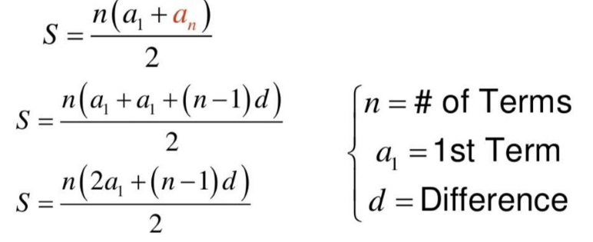
Geometric Progressions:
A geometric progression is a sequence of the form a, ar, ar², ar³, …, arⁿ, …
Where: a ∈ R is called the initial term and r ∈ R is called the common ratio.
A geometric progression is a discrete analogue of the exponential function f(x) = a rx
A common geometric progression in Computer Science is:
{an}= 1/2n
with a=1 and r=1/2
Give the initial term and the common ratio of
{b_{n}} with b_{n}= (-1)^{n}
{c_{n}} with c_{n}= 2(5)^{n}
{d_{n}} with d_{n}= 6(1/3)^{n}

Example:
Consider the finite sequence of numbers
4, 8, 16, 32, 64, 128, 256, 512, 1024
This sequence has the property that the ratio between successive terms is constant and equal to 2.
Here a = 4; r = 2.
Fibonacci Sequence:
The Fibonacci sequence, f0, f1, f2,..., is defined by the initial conditions f0 =0, f1=1, and the recurrence relation Fn = Fn-1 + Fn-2. For n=2,3,4,.... Each term is the sum of the previous two terms.
Example:
Find the Fibonacci numbers f2, f3 , f4.
- f2=f1+f0=1+0=1,
- f3=f2+f1=1+1=2,
- f4=f3+f2=2+1=3
Useful Sequences:
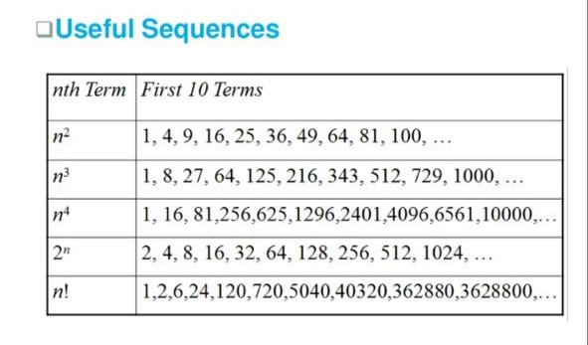
eBook Discrete Mathematics :
https://www.alamo.edu/contentassets/afe30946fa58450c89840c1173f3b9d0/sequences/math1314-arithmetic-sequences.pdf
video link: https://www.youtube.com/watch?v=7EmWdysUk0c

